**Outline of a Tres Dias Weekend**

Tres Dias weekends are lay-led, as well as structured and spontaneous. Events build slowly, with each part leading into the next.

**Thursday evening** begins with informal fellowship. A spiritual challenge is presented through two meditations. The first, “Know Thyself,” prompts self-examination. The second, “The Prodigal Son,” emphasizes God’s love and forgiveness. Both encourage introspection.

**Friday** begins with chapel and the “Three Glances of Christ” meditation. Friday’s theme is the life in grace.

**Saturday** begins with chapel and the meditation “The Figure of Christ,” which emphasizes the living Christ, as opposed to the historical figure. The theme is Christian development, creating an awareness and concern for others and desire to draw close to Him.

**Sunday** begins with the meditation “Christ’s Message to the Pescadors” encouraging believers to go forth and bear fruit while maintaining contact with Christ and each other. Christ’s command to witness and share with others is emphasized.



TRES DIAS

INTERNATIONAL

Pastors’

Corner

Unleash

the Power

of God’s Grace

in Congregations

Around the World

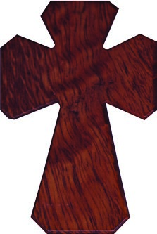

What would happen if....

•

*Seats were filled with Christians who are*

*on fire for God?*

•

*Worship and passion for Christ were as*

*contagious as the common cold?*

•

*Hands raised to volunteer for each new*

*project or ministry?*

•

*Believers served one another with love*

*and compassion...*

***all***

*the time.*

•

*Parishoners rolled up their sleeves*

*and worked side-by-side with you to*

*accomplish the work of the Lord.*

***What if you didn’t have to do it all alone?***

Actually, you don’t! God never intended for

church to be a spectator sport. Nor did he intend

for pastors to work alone in their calling. Since

the beginning, God’s goal has always been that

we become mature believers in Christ so we

can partner with pastors to make disciples of all

men. In addition to His calling, He provides you

with a variety of tools to help you accomplish His

mission.

***TRES DIAS can be one of them!***

On each of the three days, the spiritual directors offer and lead the community in Holy Communion. Each day builds on the previous day. Similarly, each talk or “rollo” builds on the previous talk. There are 15 talks in all: 10 given by laity, and five given by clergy. The talks progress from understanding to love. The talks include:

**Friday:** **Saturday: Sunday:**

1. IDEALS 6) STUDY 11) ENVIRONMENTS
2. GRACE* 7) SACRED 12) LIFE IN GRACE*
3. CHURCH MOMENTS 13) CHRISTIAN
4. HOLY SPIRIT* OF GRACE* COMMUNITY
5. PIETY 8) ACTION IN ACTION
   1. OBSTACLES 14) REUNION GROUPS TO GRACE* 15) THE FOURTH DAY
   2. LEADERS

*\* Talks given by spiritual directors*

As the weekend progresses, each table group forms a community. As each table group shares with the larger group, a larger community forms. The weekend culminates as the entire community shares in Communion -- one in Christ.

**O**ur world is in great need of Christians who blaze with God’s love. Tres Dias is a spark that ignites the fires in our hearts so we may burn brightly in our world as we share Christ with others.

Beginning on Thursday night and finishing on Sunday afternoon, Tres Dias three-day, lay-led, cloistered weekends are designed to awaken Christians to two fundamental truths: God’s grace is real, and it is meant to be shared. Weekends bring attendees into the presence of Christ, cause them to examine their life in relation to Him, and help them realize that He is the Way.

The structure enables those who attend to become brothers or sisters in Christ, in a loving community, by the close of the weekend. Tres Dias weekends focus on those areas that Christians have in common while respecting denominational differences.

as others in your congregation attend Tres Dias.

Those who have been serving in church come back refreshed and recommitted, with a deeper focus on Jesus and a greater love for His people. Those who have never served before, step up to the plate to use their spiritual gifts and newly realized leadership skills in meaningful ways.

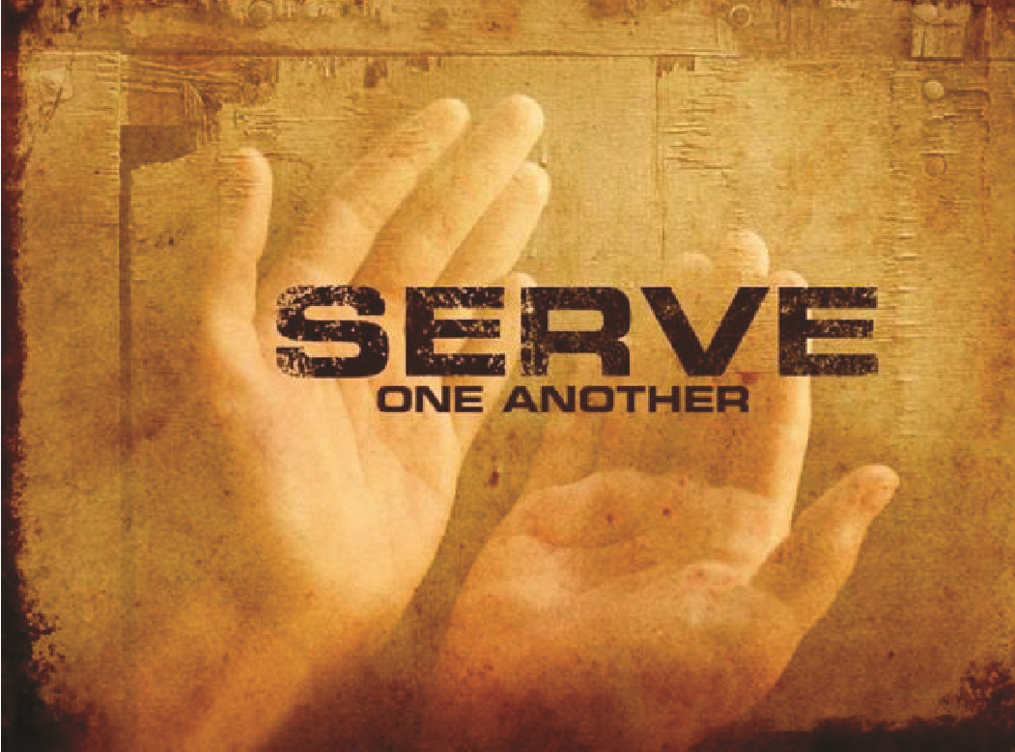The real strength of the Tres Dias ministry is that the laity emerges from the weekends with a new level of spiritual life and freedom in Christ and a greater commitment and passion to serve in their local church. Tres Dias trains servant leaders for service in their local church. It is a powerful tool the Lord has given you to use in building His kingdom. ***Churches grow when people attend Tres Dias.***



For thousands who have attended, Tres Dias has

made a life-changing difference in the quality and

depth of their spiritual walk. Faith comes alive! Love

and compassion flourish. People are energized to

share their faith and serve the Lord.

***Christians grow***

***when they attend Tres Dias.***

It only takes a spark to get a fire going. We hope

you give Tres Dias the chance to spark a wildfire

among the believers in your congregation. Pray

about who you want to bless by recommending

them to attend a Tres Dias weekend. Email us or

contact the person who gave you this brochure to

discuss how to sponsor someone to Tres Dias.



**www.TresDias.org**

**tresdias@TresDias.org**

**P**astors and the laity are called to work together to win hearts for the Lord. Tres Dias is not just about the weekends or the changes that occur in a person’s life immediately afterwards. The movement’s focus is on the continued growth and spiritual maturity of the believer for the rest of his or her life. It’s about helping Christians put piety and study into meaningful action.

As energy and passion expands to communities, there’s no limit to what new ministries develop or what long-desired outreach efforts are accomplished. Loving service to one another grows in unimaginable ways. ***Communities grow when people attend Tres Dias.*** Even pastors grow when you welcome this ministry into your church.

**What happens after Tres Dias?**

**A**fter three days on the weekend, we send these energized, revitalized, on-fire-for-Christ Christians back to their home churches ready, willing and able to love and serve the Lord.

Bible studies and small groups experience new life as these men and women hunger and thirst to know the heart of God. When people return from Tres Dias, they ***want*** to be active in their churches. For every servant leader you had, you’ll gain a half-dozen more